#Q1

import numpy as np

from scipy.stats import norm

import matplotlib.pyplot as plt

N = [1, 5, 10]

dof = 3

np.random.seed(10)

x = np.zeros((max(N), int(1e6)))

for i in range(max(N)):

    x[i] = np.random.chisquare(dof, int(1E6))

fig = plt.figure(figsize=(5, 5))

fig.subplots_adjust(hspace=0.05)

for i in range(len(N)):

    ax = fig.add_subplot(3, 1, i+1)

    x_i = x[:N[i], :].mean(0)

    ax.hist(x_i, bins=np.linspace(0,10,1000), histtype='stepfilled', alpha=0.8, density=True, label = 'chi2')

    mu = x_i.mean()

    sigma = np.sqrt(2.0*dof/N[i] )

    x_pdf = np.linspace(0, 10, 1000)

    dist = norm(mu, sigma)

    ax.plot(x_pdf, dist.pdf(x_pdf), '-k', label='gaussian')

    ax.set_xlim(0.0, 10)

    plt.legend(loc = 'center right')

    ax.text(0.99, 0.95, r"$N = %i$" % N[i], ha='right', va='top', transform=ax.transAxes)

    ax.set_xlabel(r'$x$')

    ax.set_ylabel('$p(x)$')

plt.tight_layout()

plt.show()

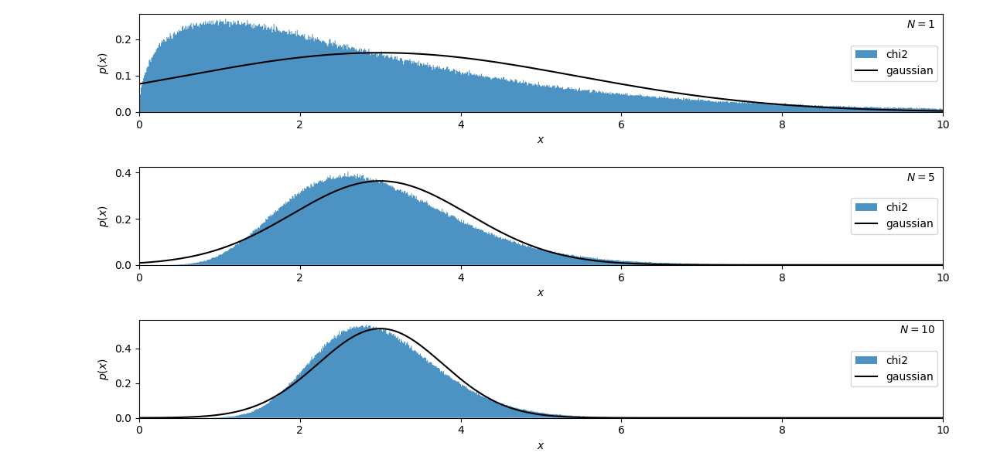

#Q2

import numpy as np

from matplotlib import pyplot as plt

import pandas as pd

from scipy.stats import kendalltau

from scipy.stats import spearmanr

from scipy.stats import pearsonr

a = pd.read_excel("C:\\Users\Heera Baiju\\Downloads\\Data Science\\Assignment 2\\LuminosityHeera.xlsx")

Luminosity = np.log(a["Lx"])

Redshift = np.log(a["z"])

# Resizing the figure

plt.figure(figsize=[7, 5])

# Plotting the scatter plot

plt.scatter(Luminosity, Redshift, c='g', alpha=0.6)

plt.title('Luminosity vs redshift', fontsize=15)

plt.xlabel('Luminosity', fontsize=13)

plt.ylabel('Redshift', fontsize=13)

plt.show()

Pearson_Correlation_Coefficient, p_value_p = pearsonr(Luminosity, Redshift)

Kendalltau_Correlation_Coefficient, p_value_k = kendalltau(Luminosity, Redshift)

Spearman_Correlation_Coefficient, p_value_s = spearmanr(Luminosity, Redshift)

print('Pearsons correlation: {}' .format(Pearson_Correlation_Coefficient))

print('p value of Pearson Correlation Coefficient: {}' .format(p_value_p))

print('Kendalltau correlation: {}' .format(Kendalltau_Correlation_Coefficient))

print('p value of Kendalltau Correlation Coefficient: {}' .format(p_value_k))

print('Spearman correlation: {}' .format(Spearman_Correlation_Coefficient))

print('p value of Spearman Correlation Coefficient: {}' .format(p_value_s))

**OUTPUT**

Pearsons correlation: 0.599835977512611

p value of Pearson Correlation Coefficient: 1.0547205916682317e-05

Kendalltau correlation: 0.44256065116630433

p value of Kendalltau Correlation Coefficient: 3.698087258609231e-05

Spearman correlation: 0.5816518730305096

p value of Spearman Correlation Coefficient: 2.2411477134735858e-05

#Q3

import numpy as np

from matplotlib import pyplot as plt

import pandas as pd

from scipy import stats

a = pd.read_excel("C:\\Users\\Heera Baiju\\Downloads\\Data Science\\Assignment 2\\Swiss Wind Power data.xlsx")

freq = a["frequency"]

windsp = a["class"]

x = np.linspace(0, 20, 1000)

k = 2

al = 6

v = np.mean(x)

def weib(x, k, al):

    return (k / al) * (x / al)**(k - 1) * np.exp(-(x / al)**k)

fig, ax = plt.subplots(figsize=(5, 3.75))

plt.plot(x, 100*weib(x, k, al), ls = '-', c='g', label = r'k=%.1f and al=%.1f' % (k, al))

plt.step(windsp, freq , ls = '-', c='black', label = r'$Data$')

plt.xlabel('$Wind\ speed\ (m/s)$')

plt.ylabel('$Frequency$')

plt.title('Weibull Distribution')

plt.xlim(0, 20)

plt.ylim(0.0, 16)

plt.legend()

plt.show()

#Q4

import numpy as np

from matplotlib import pyplot as plt

from scipy.stats import t as student_t

from scipy.stats import norm

from scipy.stats import pearsonr

mu = 0

sigma = 1

gau_x = np.linspace(-10, 10, 1000)

k = 1e10

stu_x = np.linspace(-10, 10, 1000)

fig, ax = plt.subplots(figsize=(5, 3.75))

studist = student_t(k)

plt.plot(stu_x, studist.pdf(stu_x), ls = '-', c = 'green', label = r' Student t Distribution')

dist_g = norm(mu, sigma)

plt.plot(gau_x, dist_g.pdf(gau_x), ls = '--', c = 'yellow', label = r'mean=%.1f,sigma=%.1f Gaussian Distribution' % (mu, sigma))

plt.xlim(-5, 5)

plt.ylim(0.0, 0.45)

plt.xlabel('$x$')

plt.ylabel(r'$p(x|k)\ p(x|\mu,\sigma)$')

plt.title("Student's $t$ Distribution and Gaussian Distribution")

plt.legend()

plt.show()

corr_s, p_value_s = pearsonr(stu_x, studist.pdf(stu_x))

corr_g, p_value_g = pearsonr(gau_x, dist_g.pdf(gau_x))

print('p value of Student\'s t Distribution: {}' .format(p_value_s))

print('p value of Gaussian Distribution: {}' .format(p_value_g))

